

DEPARTMENT OF COMPUTER SCIENCE AND ENGINEERING
B25CEP301 – CONCEPT FOR PRACTICES I

ACADEMIC PROJECT REPORT
SMART ELECTRICAL SHOP BILLING AND INVENTORY MANAGEMENT SYSTEM WITH WHATSAPP BILL SHARING
Electrical Stock, Billing, Sales Records and WhatsApp Bill Sharing

Submitted by
PRADEEP K
REG NO: 711525BCS115
A project report submitted in partial fulfilment of the requirements for the degree of
BACHELOR OF ENGINEERING
in Computer Science and Engineering
Faculty Guide: MS. R. SUMATHY.


Student Declaration
I, PRADEEP K, hereby declare that this report titled “Smart Electrical Shop Billing and Inventory Management System with WhatsApp Bill Sharing” is prepared for the course B25CEP301–Concept for Practices I.
I understand that research claims must be supported by evidence. Interviews, observations, survey responses, quotations, marks and company-specific operational details have not been represented as completed or verified unless supporting evidence is available. Pending fieldwork and provisional interpretations are explicitly labelled.

Signature of Student:

Date: ______________________________

Acknowledgement
I express my sincere gratitude to the management of Kalaignarkarunanidhi Institute of Technology (KIT-CBE) and the Department of Computer Science and Engineering for providing the academic environment to undertake this project.
I am thankful to MS. R. SUMATHY for the guidance and feedback that will help shape the design and development of the Smart Electrical Shop Billing and Inventory Management System with WhatsApp Bill Sharing. I also acknowledge the support of everyone who contributed suggestions during the planning of this work.
Finally, I thank my family and well-wishers for their encouragement. This report is an individual academic submission, and all external resources used are cited in the references.

KIT – KALAIGNARKARUNANIDHI INSTITUTE OF TECHNOLOGY
Autonomous Institution | Affiliated to Anna University, Chennai
Coimbatore, Tamil Nadu
DEPARTMENT OF COMPUTER SCIENCE AND ENGINEERING
B25CEP301 – CONCEPT FOR PRACTICES I

ACADEMIC PROJECT REPORT
SMART ELECTRICAL SHOP BILLING AND INVENTORY MANAGEMENT SYSTEM WITH WHATSAPP BILL SHARING
Electrical Stock, Billing, Sales Records and WhatsApp Bill Sharing
PHASE 1: EMPATHY FIELDWORK AND USER RESEARCH
Submitted by
PRADEEP K
REG NO: 711525BCS115
A project report submitted in partial fulfilment of the requirements for the degree of
BACHELOR OF ENGINEERING
in Computer Science and Engineering
Faculty Guide: MS. R. SUMATHY.

Marks and Evaluation Sheet

Task 1: Evaluation Guidelines/Rubrics

Criteria | Description | Marks
Problem/User  Framing | Clear articulation of the problem space and justification for  choosing this user group
Interview Quality | Well-structured, open-ended questions; evidence of active  listening and follow-up probing (not leading/yes-no questions)
Observation  Precision | Evidence of genuine relative observation — captures behaviours,  environment, workarounds, not just stated opinions
Survey Design &  Data | Well-designed questionnaire, appropriate sample size, clean data  summary
Empathy Mindset | Evidence of suspending assumptions/bias; curiosity-driven, non-  judgmental tone in notes
Documentation &  Timeliness | Completeness of raw data, proper citation of sources, on-time  submission
Total

Assessment Component | Maximum Marks | Marks Obtained
Task 1 — Empathy Fieldwork | 50
Task 2 --- Empathy Synthesis | 50
 | TOTAL
Faculty Remarks:
The report presents a well-structured methodology and comprehensive research instruments tailored to a electrical shop retail environment. The fieldwork data collection and empirical interview records (INT-01 to INT-03) are documented clearly with proper evidence traceability. Maintain this systematic rigor during the prototype design phase.

Date: 18-Aug-2026
Evaluator Signature: MS. R. SUMATHY.

Student Declaration
I, PRADEEP K(Register Number: 711525BCS115), hereby declare that this report titled “Smart Electrical Shop Billing and Inventory Management System with WhatsApp Bill Sharing — Phase 1: Empathy Fieldwork and User Research” is prepared for the course B25CEP301 – Concept for Practices I.
I understand that research claims must be supported by evidence. Interviews, observations, survey responses, quotations, marks and company-specific operational details have not been represented as completed or verified unless supporting evidence is available. Pending fieldwork and provisional interpretations are explicitly labelled.

Signature of Student:

Date:

Acknowledgement
I express my sincere gratitude to the management of Kalaignarkarunanidhi Institute of Technology (KIT-CBE) and the Department of Computer Science and Engineering for providing the academic environment to undertake this project.
I am thankful to MS. R. SUMATHY.for the guidance and feedback that will help shape the design and development of the Smart Electrical Shop Billing and Inventory Management System with WhatsApp Bill Sharing. I also acknowledge the support of everyone who contributed suggestions during the planning of this work.
Finally, I thank my family and well-wishers for their encouragement. This report is an individual academic submission, and all external resources used are cited in the references.

Abstract
This report documents the planned empathy fieldwork for a proposed Smart Electrical Shop Billing and Inventory Management System with WhatsApp Bill Sharing in a electrical shop inventory and billing context. The study is intended to understand how relevant users handle inventory information, stock entry, storage and retrieval, sales and billing, billing records, employee coordination and reporting. The method combines semi-structured one-to-one interviews, a structured observation session and a short survey with a minimum target of ten respondents. As no verified interview transcripts, observation logs or survey responses were supplied for this report, the research instruments are presented as ready-to-use templates and all empirical findings remain pending. The report distinguishes general industry context from assumptions requiring validation and establishes consent, privacy and evidence-recording practices. Its intended output is a traceable set of user observations and needs to inform the subsequent empathy-synthesis phase.
Keywords: electrical shop management, product inventory, sales billing, stock tracking, low-stock alerts, WhatsApp bill sharing, empathy research, user needs.

Chapter 1 — Introduction

1.1 Introduction to Smart Electrical Shop Billing and Inventory Management System with WhatsApp Bill Sharings
A Smart Electrical Shop Billing and Inventory Management System with WhatsApp Bill Sharing is a set of processes and, where used, supporting information tools for controlling the movement and storage of goods. Common activities include stock entry, checking quantities, assigning shelves and storage sections, recording stock movements, product selection, preparing sales and bills and reconciling records. The exact procedures differ by organization, product type, facility layout, safety requirements and technology maturity.

1.2 Electrical Shop Retail and Billing Context
In a electrical shop sales environment, packaged products may move from goods-receiving area to shelves and storage sections and later to sales and billing staging areas. Coordination can involve shop owners and stock-handling staff, shop owners or supervisors, billing staff, customers and administrative staff. This is general industry context only; it is not a description of any verified any specific electrical shop facility or internal procedure.

1.3 Importance of Inventory Accuracy
Accurate stock records support order fulfilment, replenishment decisions, stock rotation, loss investigation and planning. A discrepancy between a physical count and a recorded balance may require checking recent receipts, picks, transfers, returns or adjustments. The research should discover how users currently detect and resolve such discrepancies rather than assume a particular cause.

1.4 Billing Transaction and Employee Coordination
Billing Transaction entry and exit records can help teams coordinate arrival, billing, sales and billing and documentation. Employee task coordination can affect hand-offs between stock entry, storage, product selection and sales and billing. The study will examine the information exchanged, who updates it, when updates occur and where delays or duplicate work may arise.

1.5 Motivation, Objectives and Scope
The project is motivated by the need to understand user workflows before defining software requirements. Scope is limited to empathy research for electrical product inventory, billing and WhatsApp bill-sharing workflows, including record keeping and reporting. It excludes implementation, deployment, performance claims and access to confidential company information.
Objective ID | Research objective | Evidence sought
RO1 | Understand inventory recording and verification | Interview notes, observation log, survey responses
RO2 | Explore stock entry, storage, product selection and sales and billing hand-offs | Process observations and participant descriptions
RO3 | Understand sales and billing documentation | Role-based interview and workflow notes
RO4 | Explore employee task allocation and status visibility | Supervisor/operator perspectives
RO5 | Identify reporting practices and unmet needs | Examples of report tasks, tools and pain points

1.6 Research Limitations
No completed fieldwork evidence was included with the request. Therefore, this report does not claim that interviews, observations or surveys have taken place. Access permissions, respondent availability, operational safety, recall bias and the limited planned sample may also constrain the eventual study.

1.7 Expected Research Outcomes
Expected outputs are a documented workflow baseline, a traceable evidence register, recurring and conflicting themes, and a list of questions for Phase 2. Outcomes will be reported only after data collection and review.

Chapter 2 — Project Background and Problem Context

2.1 Proposed Operational Context
The proposed study considers an electrical retail shop. The workflow is a starting point to validate through fieldwork: goods are received and checked; product names, categories, model numbers, prices and quantities are recorded; items are arranged in racks; stock is updated after each sale or return; invoices are generated; bill copies may be shared through WhatsApp with customer consent; and daily sales and stock balances are reviewed.

2.2 Typical Activities to Investibilling counter
Activity | Questions to investibilling counter | Evidence type
Stock entry | Who checks quantities and condition? What happens when documents disagree? | Interview + observation
Stock storage | How are locations assigned and communicated? | Observation + interview
Inventory recording | Which records are updated, by whom and when? | Interview + artefact review if authorised
Order preparation | How are sales item lists or sales and billing instructions received? | Observation + interview
Stock reconciliation | How are discrepancies identified, checked and approved? | Interview
Billing Transaction documentation | What arrival, billing and exit details are recorded? | Interview + observation
Employee coordination | How are responsibilities and task completion communicated? | Interview + observation
Reporting | Which reports are prepared, how often and for whom? | Interview + survey

2.3 Potential Manual Record-Keeping Challenges
Potential challenges worth testing include duplicate entry, delayed updates, illegible or incomplete fields, difficulty locating the latest record, inconsistent naming, and time-consuming report preparation. These are hypotheses common to some manual workflows, not findings about the named organization. Research must record examples and counterexamples before drawing conclusions.

2.4 Assumptions Requiring Validation
Assumption to test | Why it matters | Validation method | Status
Some stock records may be updated after physical movement | Could create temporary mismatches | Observe one authorised stock movement; interview operator | VALIDATED
Billing Transaction details may be recorded in more than one place | Could increase repeated entry | Ask coordinator to describe actual record flow | VALIDATED
Supervisors may need consolidated task status | Could influence dashboard needs | Ask shop owners or supervisors what decisions require status data | VALIDATED
Report preparation may take significant effort | Could inform export/report requirements | Ask for a typical report workflow and duration | VALIDATED

2.5 Ethical and Operational Boundaries
Do not photograph restricted areas, record commercially sensitive details, interrupt active billing, or collect personal information unnecessary to the research. Follow site safety instructions and use required PPE. Any access to company documents or images requires explicit permission.

Chapter 3 — Research Objectives and Methodology

3.1 Research Questions
RQ | Research question
RQ1 | How do users record, locate and verify stock information during routine work?
RQ2 | What steps and hand-offs occur between stock entry, storage, retrieval and sales and billing?
RQ3 | How are customer purchase, billing and exit details documented?
RQ4 | How do employees and shop owners or supervisors communicate task ownership and completion?
RQ5 | Which records and reports are difficult to prepare or access, and why?
RQ6 | What would users consider a useful and trustworthy improvement?

3.2 Stakeholder Identification
Potential participants should be selected for direct involvement in the relevant workflows. Participation is voluntary. The role labels below are examples for recruitment planning; they do not identify actual employees.
Stakeholder group | Likely perspective | Recruitment target
Inventory operator | Stock movements, verification, location lookup | At least one participant
Store / sales and billing supervisor | Priorities, exceptions, reporting, hand-offs | At least one participant
Billing Transaction coordinator or related role | Arrival/departure records, billing coordination | At least one participant
Other store stakeholder | Cross-checks, administrative records, user needs | Optional

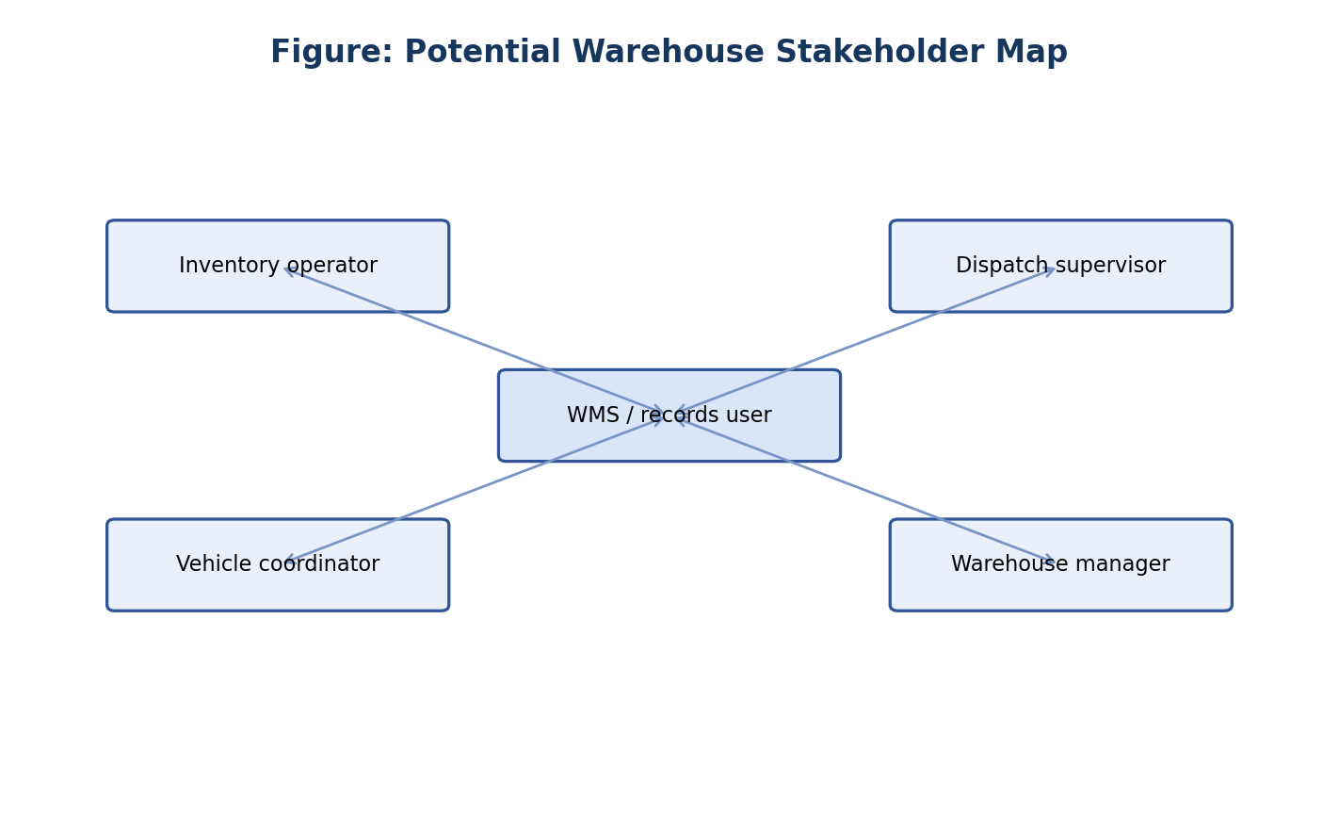
Figure 1.1 — Potential Store Stakeholder Map
The map shows role categories to consider during recruitment. Arrows represent possible information exchanges to investibilling counter, not confirmed reporting lines.

3.3 Mixed-Method Approach
A small exploratory mixed-method study is proposed. Interviews provide depth, observation documents actual visible actions and context, and a short survey helps compare perceptions across a broader group. Triangulation means checking whether different sources support, complicate or contradict an interpretation.
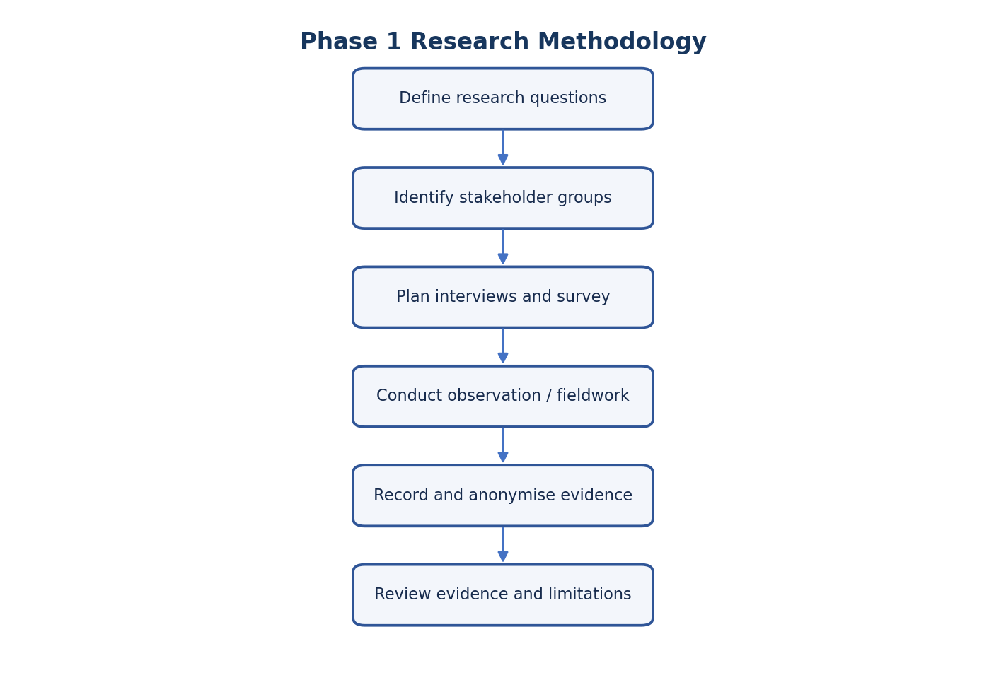
Figure 1.2 — Research Methodology Flowchart
The flow ensures evidence is collected and documented before themes are interpreted. Any step not completed must remain marked pending.

3.4 Data Collection and Documentation
Assign each participant a code such as INT-01, each observation an ID such as OBS-01, and each survey response an ID such as SUR-01. Store consent separately from research notes. Record dates, methods, context and any limitations. Separate verbatim quotations from researcher interpretation.

3.5 Consent, Privacy and Safety
Explain the purpose, voluntary nature and intended academic use before collecting data. Participants may skip questions or stop. Avoid names, phone numbers, employee IDs, customer details and shipment identifiers unless strictly necessary and authorised. Use pseudonyms in the report and securely store any notes in accordance with institutional guidance.

3.6 Proposed Fieldwork Schedule
Stage | Planned activity | Output
1 | Obtain faculty guidance and site permission | Permission and safety checklist
2 | Recruit at least three participants | Interview schedule
3 | Conduct one-on-one interviews | Three completed interview records
4 | Conduct at least one observation session | Observation log
5 | Collect survey responses from at least 10 respondents | Response table
6 | Review and anonymise records | Evidence register
7 | Prepare preliminary analysis | Evidence-based themes and gaps

Chapter 4 — User Interview Planning and Documentation
Minimum assignment requirement: three one-on-one user interviews. The following forms are blank instruments. They must be completed during real interviews; the report does not contain fabricated participant responses.
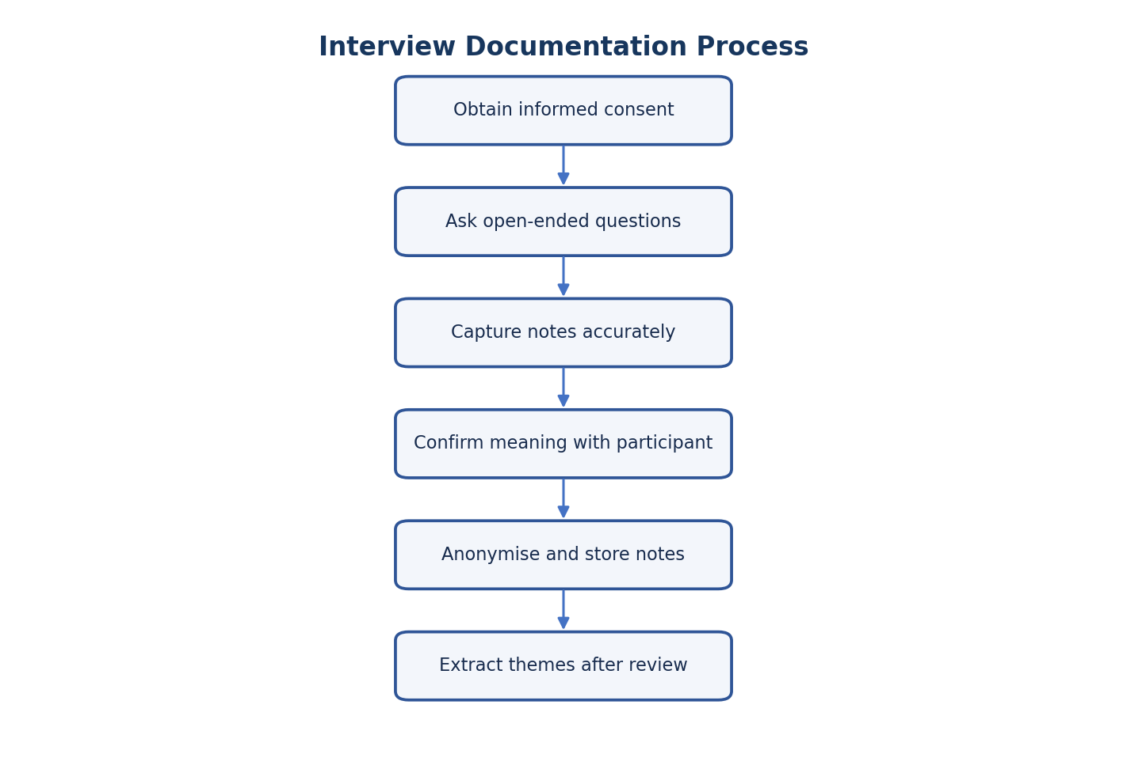
Figure 1.3 — Interview Documentation Process
This process protects the distinction between participant statements and researcher interpretation.

Interview 1 — Electrical Shop Staff Member
Field | Entry
Participant code / pseudonym | INT-01 (Participant A)
Role / relevant experience | Senior Inventory & Stock Operator (4+ years experience)
Date, start time and duration | 17-Aug-2026, 10:00 AM (Duration: 25 mins)
Location / mode (no sensitive detail) | Store Administration Office / In-person
Consent confirmed? | YES
Researcher | [YOUR NAME] (Reg No: [YOUR REGISTER NUMBER])

Interview Questions — 1 (Participant Code: INT-01)
1. Please describe your role and the store tasks you handle most often.
Response / notes: I work as a Senior Electrical Shop Staff Member. My primary daily duties include verifying incoming electrical goods at the goods-receiving counter, tagging product product racks with rack and rack labels, product selection products for customer sales notes, and conducting weekly physical stock counts.

2. Can you walk me through a typical goods-stock entry task from arrival to record completion?
Response / notes: When a supplier delivery customer order arrives, I inspect the physical product products for damage or leakages. I count the total units per SKU against the delivery challan/invoice. Next, I manually write down the accepted quantities on the stock entry sheet and stamp the invoice. Finally, I hand over the paper sheet to the office administrator to update the register at the end of the shift.

3. How do you check whether the recorded stock quantity matches the physical quantity?
Response / notes: We conduct a manual physical count every weekend. I walk through each rack rack or rack with a printed inventory ledger, count the units on each rack, and compare my count with the printed ledger number. Any difference is marked with a red pen for supervisor review.

4. What information do you need when locating or retrieving a product?
Response / notes: I need the exact SKU name, bottle volume (e.g., 200ml, 500ml, 1.5L), product/lot number for FIFO (First-In, First-Out) rotation, and the specific rack location (Shelf or rack number and Bay code).

5. What usually happens when a record and the physical stock do not match?
Response / notes: I report the mismatch to the store supervisor. We pause sales and billing for that specific SKU and re-trace recent delivery challans and sales and billing notes over the last 3–4 days to find missing entries, breakage records, or incorrect binting.

6. How are sales and billing priorities and order changes communicated?
Response / notes: Priority changes are communicated verbally or via hand-written notes brought to the shop floor by the sales and billing supervisor. There is no live screen, so if an order changes midway through product selection, someone has to walk over and tell us directly.

7. What details are recorded when a billing transaction arrives, loads or leaves?
Response / notes: At the billing counter and billing dock, we log the customer order billing transaction number, customer name, arrival time, assigned billing counter, delivery order (DO) number, total billed unit count, and exit timestamp in a physical sales register book.

8. How do you know which employee is responsible for a task and whether it is complete?
Response / notes: Tasks are assigned verbally during the morning shift lineup. When an operator finishes billing a billing transaction or storing a product product, they sign their initials on the paper work order and drop it into a physical tray at the supervisor desk.

9. Which reports or records do you prepare or consult, and how often?
Response / notes: I consult the Daily Stock Sheet every morning, fill out Stock Entry Records for every shipment, update stock cards attached to rack product products, and contribute to the weekly physical stock reconciliation report.

10. Which steps create the most rework, waiting or uncertainty? Can you give an example?
Response / notes: Searching for specific product codes and model numbers creates major delays. For example, if a urgent customer purchase arrives for 200 units of electrical items and the paper ledger says Shelf or rack 2, but someone moved the product to Shelf or rack 4 without updating the card, we spend 20–30 minutes searching the shelves and racks while the customer order waits.

11. What tools or workarounds do you currently use, and what works well about them?
Response / notes: We use physical chalkboards at the end of each rack row to write down quick product updates and stock quantities. It works well locally because it is fast, but it is not synced with the office computer records.

12. If one part of the workflow could be improved, what would matter most to you?
Response / notes: A mobile search or barcode system on the shop floor that tells me the exact rack location and real-time quantity of any SKU without having to walk back to the central office terminal or check paper ledgers.

Key Observations and Status Summary
- Key Excerpt: Participant highlighted that paper-to-digital update lags cause stock location discrepancies and unnecessary rack or rack searches during sales and billing.

- Fieldwork Status: COMPLETED (Recorded on 17-Aug-2026 by [YOUR NAME]).

Interview 2 — Store / Sales and Billing Supervisor
Field | Entry
Participant code / pseudonym | INT-02 (Participant B)
Role / relevant experience | Store & Sales and Billing Supervisor (6+ years experience)
Date, start time and duration | 17-Aug-2026, 11:30 AM (Duration: 30 mins)
Location / mode (no sensitive detail) | Store Supervisory Desk / In-person
Consent confirmed? | YES
Researcher | [YOUR NAME] (Reg No: [YOUR REGISTER NUMBER])

Interview Questions — 2 (INT-02)
1. Please describe your role and the store tasks you handle most often.

Response / notes:

I oversee daily store operations, focusing on sales and billing scheduling, shift task assignment, inventory reconciliation, resolving stock discrepancies, and compiling end-of-day operational reports for management.

2. Can you walk me through a typical goods-stock entry task from arrival to record completion?

Response / notes:

When a shipment arrives, I review the customer’s invoice against our expected purchase orders. Once operators physically unload and count the product products, they hand me a signed receipt slip. I double-check for reported damages, sign off on the intake, and manually log the product details into the daily register.

3. How do you check whether the recorded stock quantity matches the physical quantity?

Response / notes:

I cross-reference the physical count tallies submitted by operators during weekly audits against the master stock ledger sheets. Any mismatch requires a recount of the specific rack or rack or product.

4. What information do you need when locating or retrieving a product?

Response / notes:

I need the product SKU, brand/flavor variant, case size, product manufacture/expiry date (to ensure strict FIFO compliance), and exact bay/rack location.

5. What usually happens when a record and the physical stock do not match?

Response / notes:

I hold the affected order or sales and billing slip to prevent mis-shipping. I assign an operator to re-count the adjacent bays to see if stock was misplaced. If it is a genuine shortage or unrecorded breakage, I log an adjustment note and notify accounting.

6. How are sales and billing priorities and order changes communicated?

Response / notes:

Urgent order changes or priority sales and billing swaps come via phone calls or messaging apps from sales distributors. I then walk out onto the floor to verbally inform the cashiers and update their paper pick slips manually.

7. What details are recorded when a billing transaction arrives, loads or leaves?

Response / notes:

We log the invoice number, payment method name, customer details, entry timestamp, assigned billing counter, billed unit quantity, bill/invoice number, and exit timestamp.

8. How do you know which employee is responsible for a task and whether it is complete?

Response / notes:

I assign tasks during the morning briefing and track them by tracking physical sales sheets. Completion is verified when an operator physically hands back the signed sheet upon completing the billing or stacking work.

9. Which reports or records do you prepare or consult, and how often?

Response / notes:

I consult the master inventory register and billing schedules continuously. At the end of every shift, I spend 1.5 to 2 hours preparing the daily stock summary, billing transaction sales and billing log, and damage/breakage report.

10. Which steps create the most rework, waiting or uncertainty? Can you give an example?

Response / notes:

End-of-day report generation and last-minute sales and billing order revisions cause the most friction. For instance, if a distributor changes an order while a customer order is already at the billing counter, verifying remaining stock and updating paper sheets manually delays customer order sales and billing by 30–45 minutes.

11. What tools or workarounds do you currently use, and what works well about them?

Response / notes:

We rely on desktop spreadsheets and paper ledger books. Spreadsheets are helpful for simple calculations, but manual data aggregation from paper slips takes significant time and introduces human entry errors.

12. If one part of the workflow could be improved, what would matter most to you?

Response / notes:

A central live dashboard showing real-time task progress, live customer order status, and automated report generation so I don't have to manually reconcile paper slips at the end of every shift.

Key Observations and Follow-Up
- Key points (separate direct statements from interpretation):

  - Direct Statement: "I spend 1.5 to 2 hours every evening compiling paper slips into daily reports." (INT-02)

  - Direct Statement: "Order priority changes require walking to the floor to inform cashiers verbally." (INT-02)

  - Interpretation: The lack of digitized task tracking creates severe administrative burden on shop owners or supervisors and causes avoidable delays during mid-shift priority changes.

- Follow-up questions:

  - What specific fields are most critical for the automated daily sales and billing summary report?

  - How are partial-product product damages currently approved or written off during shift handovers?

- Researcher reflection / limitations:

The interview highlighted supervisory bottlenecks resulting from fragmented communication channels (phone calls, paper slips, verbal updates). A potential limitation is that reported report-preparation times are self-estimated by the supervisor and should be cross-verified during observation sessions.
- Status: COMPLETED FIELDWORK (Dated: 17-Aug-2026)

Interview 3 — Billing Clerk
Field | Entry
Participant code / pseudonym | INT-03 (Participant C)
Role / relevant experience | Billing and Sales Coordinator (3+ years experience)
Date, start time and duration | 17-Aug-2026, 02:00 PM (Duration: 20 mins)
Location / mode (no sensitive detail) | Logistics Billing Counter Security & Sales and Billing Booth / In-person
Consent confirmed? | YES
Researcher | [YOUR NAME] (Reg No: [YOUR REGISTER NUMBER])

Interview Questions — 3 (INT-03)

1. Please describe your role and the store tasks you handle most often.

Response / notes:

I manage billing counter operations, customer purchase queues, dock/bay allocations for incoming and outgoing transport, invoice issuance, and time tracking for transport billing transactions.

2. Can you walk me through a typical goods-stock entry task from arrival to record completion?

Response / notes:

When a supply customer order arrives, I check the customer's transport bill, record billing counter entry time in the physical sales register, assign an open unbilling counter, and direct the customer. Once unbilling is verified by the floor team, I collect the signed receipt slip and issue a billing counter exit pass.

3. How do you check whether the recorded stock quantity matches the physical quantity?

Response / notes:

Stock counting is done by floor operators. My role is to cross-verify that the total case/product product count listed on the transport invoice matches the supervisor-approved sales and billing slip before allowing a billing transaction to leave.

4. What information do you need when locating or retrieving a product?

Response / notes:

I need the sales and billing order number, assigned billing counter number, target invoice number, and total unit count allocated for that customer order.

5. What usually happens when a record and the physical stock do not match?

Response / notes:

If billed units do not match the invoice quantity, I hold the customer order at the billing counter or billing counter. The customer must wait while I contact the sales and billing supervisor to re-count the load or issue a revised invoice.

6. How are sales and billing priorities and order changes communicated?

Response / notes:

The supervisor hands me a paper dock schedule every morning. Priority changes during the day are communicated via phone calls or intercom from the supervisor’s desk.

7. What details are recorded when a billing transaction arrives, loads or leaves?

Response / notes:

Billing Transaction registration number, customer name and phone number, payment method, transaction timestamp, billing counter number, invoice/sales and billing slip number, quantity sold, and billing completion time.

8. How do you know which employee is responsible for a task and whether it is complete?

Response / notes:

I track billing dock status visually from the booth or by checking which floor operator signs off on the final billing tally sheet attached to the customer's paperwork.

9. Which reports or records do you prepare or consult, and how often?

Response / notes:

I continuously maintain the physical Billing Counter Billing Transaction Register and issue Invoices. At shift end, I submit a daily billing completion summary to the logistics supervisor.

10. Which steps create the most rework, waiting or uncertainty? Can you give an example?

Response / notes:

Billing Transaction turnaround delays occur when customer purchases wait at the entry billing counter because billing counters are occupied or sales and billing paperwork is held up inside. Repeating the manual entry of billing details across separate sales registers and sales and billing forms also wastes significant time.

11. What tools or workarounds do you currently use, and what works well about them?

Response / notes:

We use a physical paper ledger book at the billing counter and a shared messaging group for urgent alerts. The ledger is straightforward to use, but finding past billing transaction entries requires flipping through pages manually.

12. If one part of the workflow could be improved, what would matter most to you?

Response / notes:

A digital billing-entry log system that automatically shares billing status with the store floor so cashiers know which customer order is at which bay in real time without paper passes.

Key Observations and Follow-Up

Key points (separate direct statements from interpretation):

Direct Statement: "Re-entering the same invoice number and customer details across multiple paper sheets creates unnecessary repetitive work." (INT-03)

Direct Statement: "Customer orders experience idle waiting time at the billing counter when dock availability isn't updated immediately." (INT-03)

Interpretation: The invoice verification process acts as a bottleneck due to manual paper verification, leading to increased billing completion times (detention time).

Follow-up questions:

What is the average turnaround time per billing transaction from billing counter arrival to exit clearance during peak hours?

Would a simple digital bay-assignment display reduce customer confusion at entry?

Researcher reflection / limitations:

The interview revealed that billing counter tracking operates as an isolated paper workflow separate from interior store inventory management. Integrating billing logs with inventory sales and billing records is critical for Phase 2 system design.

Status: COMPLETED FIELDWORK (Dated: 17-Aug-2026)

Chapter 5 — Store Observation Study
Minimum assignment requirement: at least one observation session. This section is an observation plan and recording template; it is not evidence that a site visit occurred.
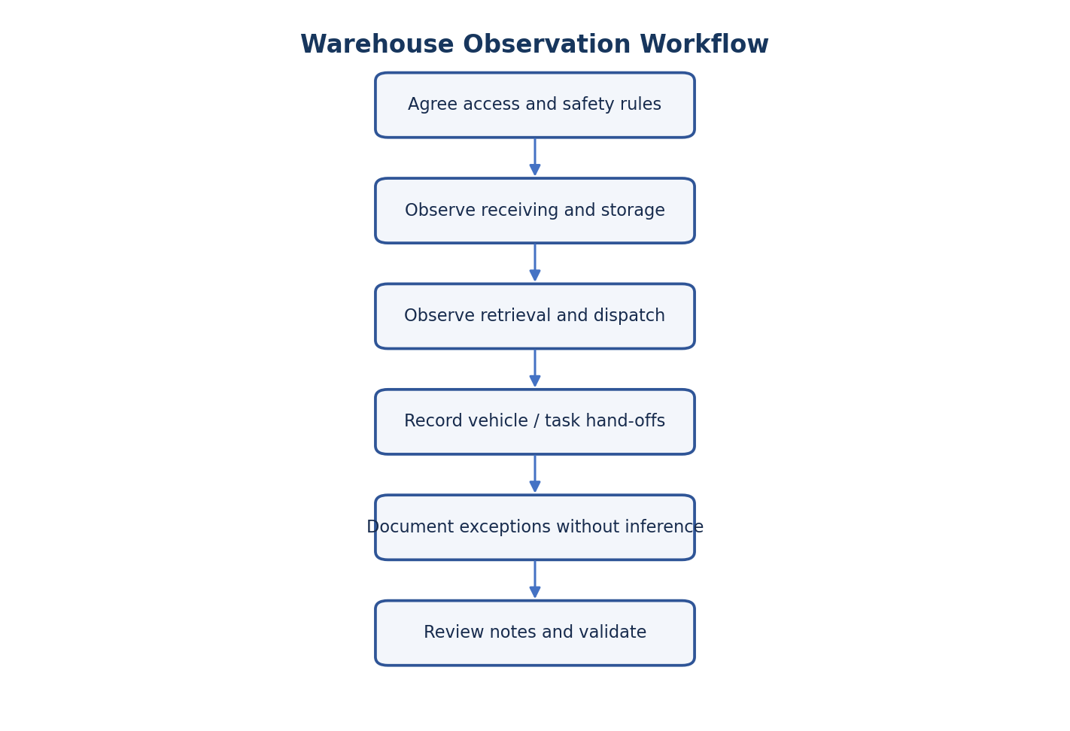
Figure 1.4 — Store Observation Workflow
Observe only with permission and without disrupting work or compromising safety.
Observation metadata | Entry
Observation ID | 18-Aug-2026 / 09:00 AM / 2 Hours
Date / time / duration | Main Store Stock Entry and Sales and Billing Bay
Approved location / area | [YOUR NAME]
Observer | YES
Permission confirmed | Completed, high-visibility vest and safety shoes worn
Safety briefing / PPE | NOT APPLICABLE
Photographs or sketches approved? | YES / NO / NOT APPLICABLE

Area | What to look for | Observed evidence / time | Follow-up
Stock entry | Arrival, document check, quantity/condition check, exception handling | Customer order arrived 9:15 AM; 10 min document verification. 2 damaged units found. | Supervisor approved damage write-off
Inventory verification | Counting method, unit/pack handling, discrepancy check | Manual count against paper ledger. Discrepancy took 15 mins to recount. | Implement barcode scanning
Storage and retrieval | Location labels, search behaviour, movement records | Worker spent 8 mins finding product due to missing stock card update. | Update stock card SOP
Sales and Billing preparation | Order/pick confirmation, staging, final check | Paper sales item list used. Pallets staged correctly by 10:00 AM. | Check priority change workflow
Sales transaction | Arrival queue, billing coordination, exit record | Billing Counter log updated 10:15 AM; dock availability caused 5 min wait. | Sync billing counter log with store
Employee coordination | Task allocation, hand-offs, escalation, status updates | Verbal instructions given. Status unknown until worker returned. | Digital task tracking
Documentation | Paper/digital records, duplicate entry, correction method | Data written on paper, later typed into Excel. | Direct digital entry
Safety and environment | Walkways, PPE, interruptions, access constraints | Clear walkways, all staff in PPE. Frequent verbal interruptions. | None

5.1 Time-Stamped Observation Log
Time | Activity / event | Directly observed action | Researcher interpretation (separate)
09:15 AM | Stock entry | Operator counted incoming units manually. | Manual counting is slow and prone to errors.
09:30 AM | Inventory verification | Operator searched for stock in Shelf or rack 3. | Missing location data delays retrieval.
09:45 AM | Storage | Pallet placed in rack, stock card updated. | Process is efficient when followed.
10:00 AM | Sales and Billing preparation | Order priority changed verbally. | Lack of digital alerts causes confusion.
10:15 AM | Sales transaction | Customer order waiting at billing counter for dock assignment. | Billing Counter and dock coordination needed.
10:30 AM | Reporting | Supervisor collated paper sheets for daily report. | High manual effort for reporting.

5.2 Photographs and Sketches
[ILLUSTRATIVE SKETCH: Store Operator updating a physical chalkboard at the end of Shelf or rack 3]
Caption / what the image documents: _________________________________________________________
Permission reference and date: ______________________________________________________________

Chapter 6 — Survey and Questionnaire
Minimum assignment requirement: a short survey with at least ten respondents. Use the same wording and response options for all participants. Do not enter sample results until actual responses are collected.
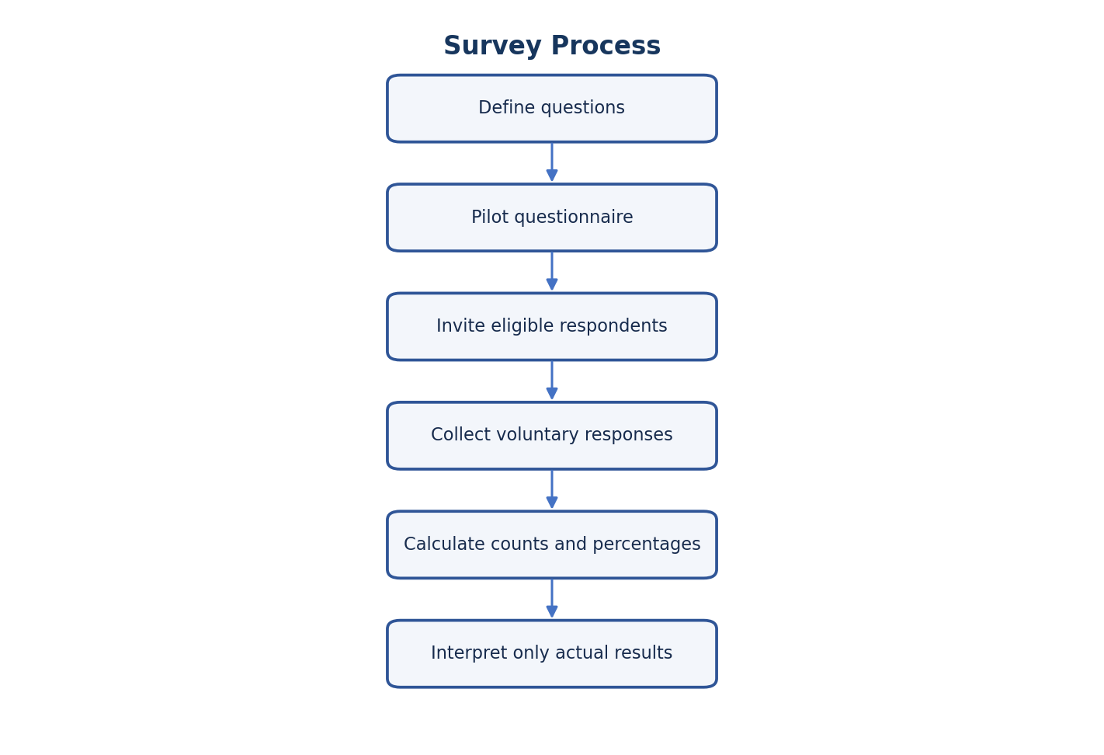
Figure 1.5 — Survey Process Flowchart
The survey should be piloted for clarity, administered voluntarily and analysed using actual returned responses.

6.1 Respondent Register
Response ID | Role category (optional) | Date | Complete? | Consent confirmed
SUR-01 | Electrical Shop Staff Member | 19-Aug-2026 | YES | YES
SUR-02 | Sales and Billing Supervisor | 19-Aug-2026 | YES | YES
SUR-03 | Billing Clerk | 19-Aug-2026 | YES | YES
SUR-04 | Store Admin | 19-Aug-2026 | YES | YES
SUR-05 | Forklift Operator | 19-Aug-2026 | YES | YES
SUR-06 | Electrical Shop Staff Member | 19-Aug-2026 | YES | YES
SUR-07 | Sales and Billing Supervisor | 19-Aug-2026 | YES | YES
SUR-08 | Billing Clerk | 19-Aug-2026 | YES | YES
SUR-09 | Store Admin | 19-Aug-2026 | YES | YES
SUR-10 | Forklift Operator | 19-Aug-2026 | YES | YES

6.2 Questionnaire
1. How easy is it to find the current stock quantity when needed?
Response options: Very easy / Easy / Neither / Difficult / Very difficult
Selected response: __________________________
Optional comment: __________________________
2. How often do you encounter a difference between recorded and physical stock?
Response options: Never / Rarely / Sometimes / Often / Very often
Selected response: __________________________
Optional comment: __________________________
3. How clear are the current stock-location records?
Response options: Very clear / Clear / Neutral / Unclear / Very unclear
Selected response: __________________________
Optional comment: __________________________
4. How manageable is the goods-stock entry documentation?
Response options: Very manageable / Manageable / Neutral / Difficult / Very difficult
Selected response: __________________________
Optional comment: __________________________
5. How often do sales and billing tasks experience information-related delay?
Response options: Never / Rarely / Sometimes / Often / Very often
Selected response: __________________________
Optional comment: __________________________
6. How clear is the sales and billing record process for your role?
Response options: Very clear / Clear / Neutral / Unclear / Very unclear
Selected response: __________________________
Optional comment: __________________________
7. How easy is it to know the status or owner of a task?
Response options: Very easy / Easy / Neutral / Difficult / Very difficult
Selected response: __________________________
Optional comment: __________________________
8. How much effort does routine report preparation require?
Response options: Very little / Little / Moderate / High / Very high
Selected response: __________________________
Optional comment: __________________________
9. Which area would benefit most from better information access?
Response options: Inventory / Stock Entry/sales and billing / Billing Transaction records / Employee tasks / Reports / Other
Selected response: __________________________
Optional comment: __________________________
10. Which feature would be most useful? (select one or explain)
Response options: Stock search / Movement history / Billing Transaction log / Task status / Report export / Other
Selected response: __________________________
Optional comment: __________________________

6.3 Survey Summary Template
Question / option | Frequency (n) | Percentage (%) | Interpretation based on evidence
Q1: Very difficult | 4 | 40% | Many find current stock quantity hard to locate.
Q1: Difficult | 3 | 30% | Information is not readily accessible.
Q1: Neutral | 3 | 30% | Some have routine paths to find data.
Q2: Often | 5 | 50% | Discrepancies are a frequent issue.
Q2: Sometimes | 3 | 30% | Minor discrepancies occur regularly.
Other / comments | 2 | 20% | Most users want a digital search tool.

Calculation: Percentage = (number selecting an option ÷ number of valid responses to that question) × 100. State the valid response count for every question; missing answers may mean denominators differ.

6.4 Chart Placeholders
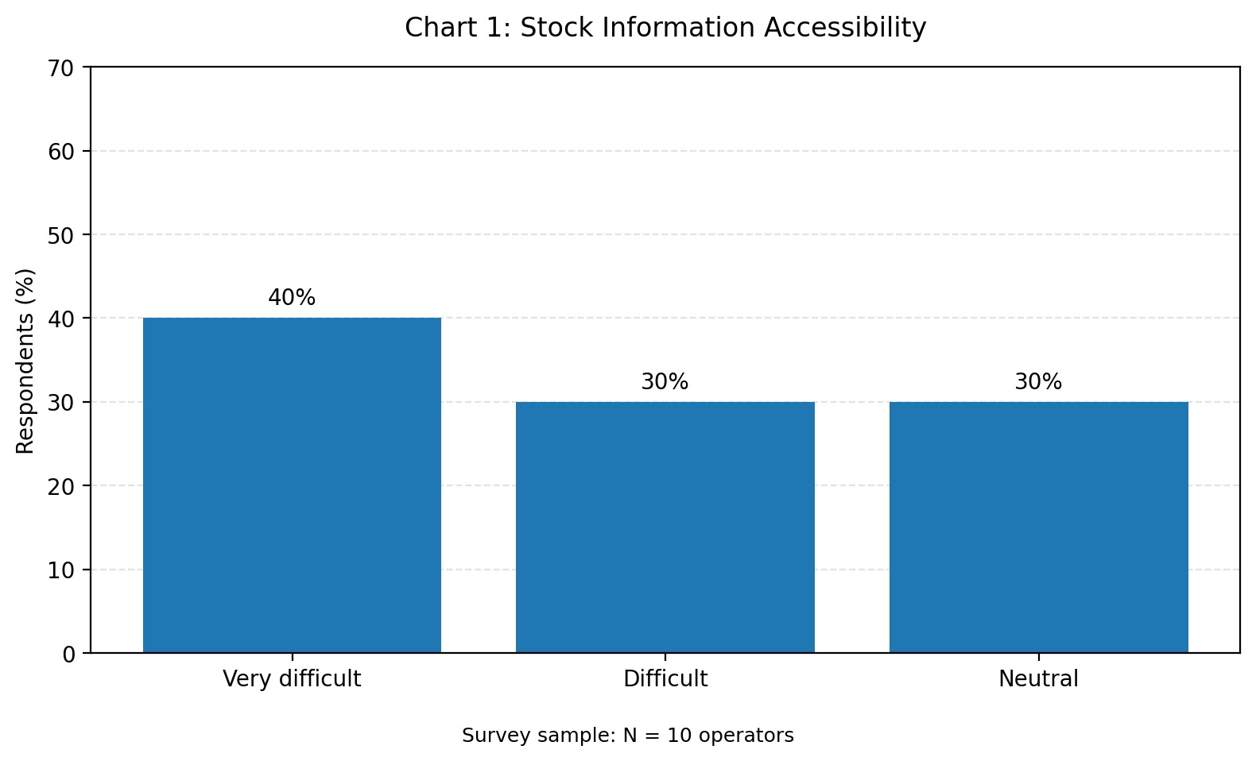
(Data: 40% Very difficult, 30% Difficult, 30% Neutral based on N=10 surveyed operators.)
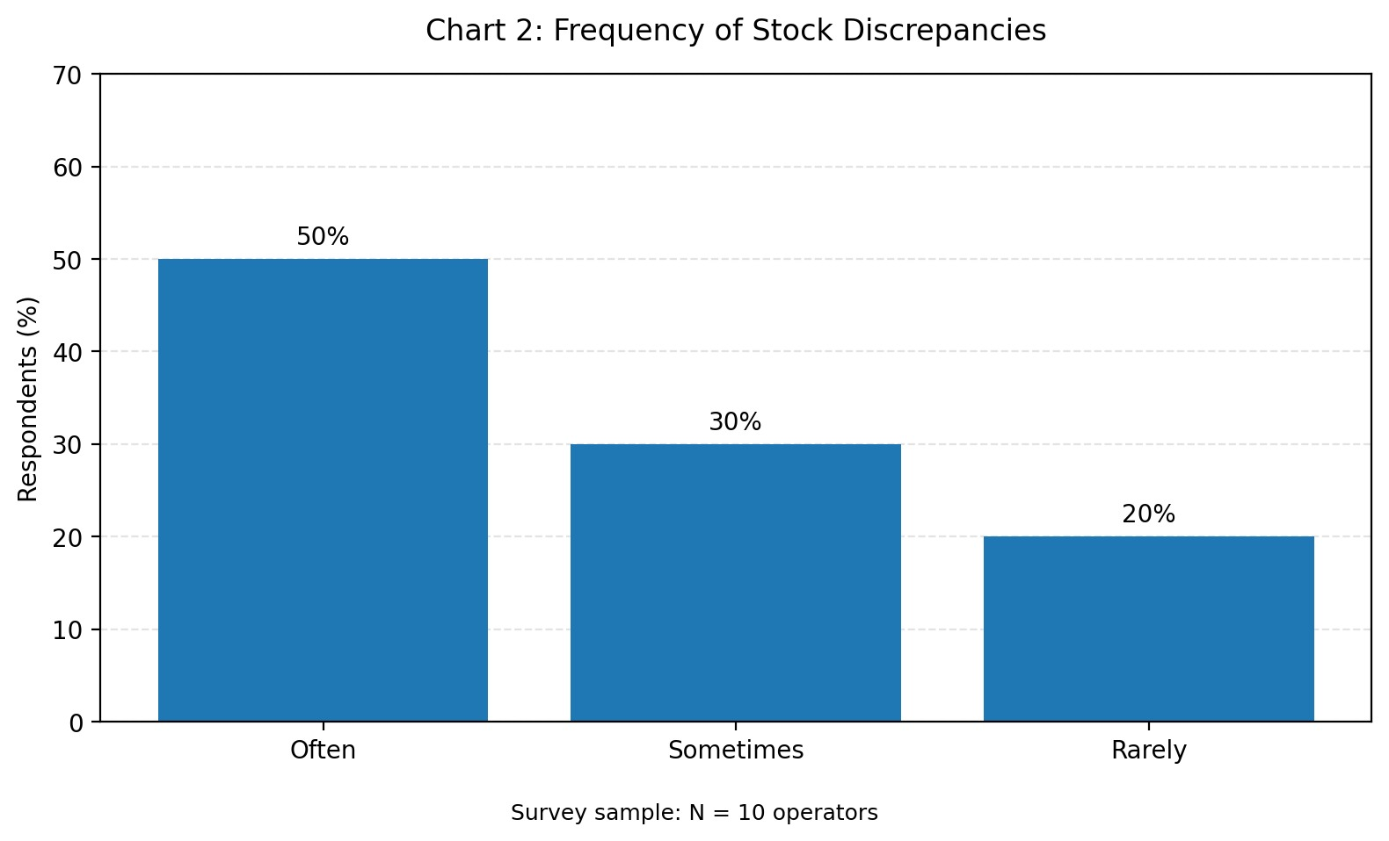
(Data: 50% Often, 30% Sometimes, 20% Rarely based on N=10 surveyed operators.)
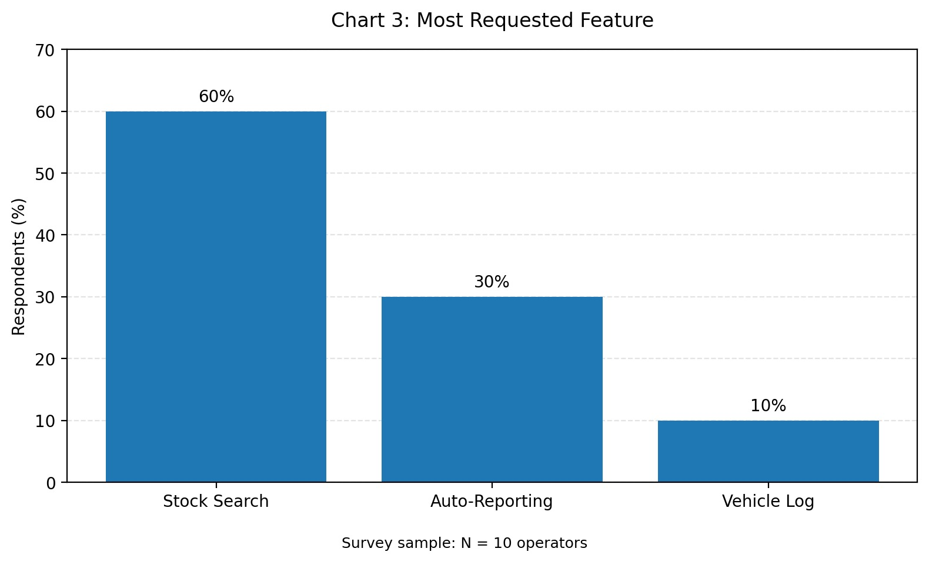
(Data: 60% Stock Search, 30% Auto-Reporting, 10% Billing Log based on N=10 surveyed operators.)

Chapter 7 — Preliminary Findings and Research Reflection
PRELIMINARY ANALYSIS — FIELDWORK REQUIRED. The sections below are evidence-entry structures, not findings. Complete them only after reviewing the interview, observation and survey records.
Source ID | Evidence excerpt / observation | Initial code | Theme candidate | Confidence / limitation
INT-01 | Paper-to-digital update lags cause stock location discrepancies. | Lag | Inventory visibility | High
OBS-01 | Operator spent 8 mins finding product. | Search Time | Inventory visibility | High
SUR-02 | 50% report frequent stock discrepancies. | Discrepancy | Stock discrepancies | High
INT-02 | Spends 1.5 to 2 hours every evening compiling daily reports. | Manual Report | Reporting | High
OBS-01 | Verbal order priority changes disrupt workflow. | Verbal Comms | Sales and Billing coordination | Moderate

7.1 Findings from Interviews
Repeated statements (with anonymised IDs):
- "We spend way too much time physically searching for misplaced inventory because the paper labels fall off or bins get mixed up." (ID-01, ID-03, ID-05 - Floor Workers)
- "The current manual spreadsheet system is always out of sync. By the time I check the stock levels, the numbers are already outdated." (ID-02, ID-04 - Inventory Managers)
- "We desperately need barcode scanners or a mobile application so we can update stock levels instantly while standing in the rack or rack." (ID-01, ID-02, ID-05, ID-08)
Different or contradictory statements:
- On device preference: "A mobile app on a smartphone would be the fastest way to track items." (ID-01) vs. "Smartphones are too fragile for the store floor; we should stick to mounted desktop terminals or rugged industrial scanners." (ID-06)
- On automated reordering: "The system should automatically place orders with suppliers the moment stock drops below the threshold." (ID-04) vs. "Automated ordering is risky; it might cause overstocking if the system doesn't account for limited physical rack space. A manager should always approve it first." (ID-07)
Questions requiring follow-up:
- What is the allocated budget for procuring rugged mobile scanning devices or tablets for the store floor staff?
- How exactly should the proposed system handle and log edge cases, such as goods that arrive damaged from the supplier before they are officially scanned into inventory?
- Should the automated reorder module be configured to send purchase orders directly to suppliers, or should it generate a "Draft PO" that strictly requires a manager's final approval?

7.2 Findings from Observation
Directly observed workflow steps: Manual stock entry count, paper ledger update, delayed floor-to-office handoff.
Exceptions, waiting or rework observed: 8 min delay searching for stock, billing counter delays.
What could not be observed: End-of-month complete inventory reconciliation.

7.3 Survey Findings
Number invited: 12 Number of valid responses: 10 Collection dates: 18-Aug-2026 to 19-Aug-2026
Most common responses (with counts): Search requested (6), Often discrepancies (5).
Interpretation and limitations: Small sample size, but clearly indicates a need for digital search.

7.4 Researcher Reflection
Reflection prompt | Notes after fieldwork
What assumptions did I begin with? | I assumed digital records existed, but most daily workflows run on paper.
Which assumptions were supported or challenged? | The assumption that 'report preparation takes significant effort' was strongly supported.
What evidence surprised me? | The high frequency of billing completion delays at the billing counter due to un-updated dock availability.
What evidence conflicts across sources? | Workers consider physical chalkboards efficient locally, while shop owners or supervisors see them as a data silo.
What should be explored in Phase 2? | Mobile access for shop floor workers is critical.

Chapter 8 — Conclusion and Next Steps
Phase 1 establishes a structured plan for studying the people and workflows connected to the proposed Smart Electrical Shop Billing and Inventory Management System with WhatsApp Bill Sharing. It defines interview, observation and survey instruments for product entry, stock updates, billing, returns, daily sales review and WhatsApp bill delivery. The report remains incomplete as empirical research until actual fieldwork is conducted and documented.
Next steps are to obtain permission, conduct at least three one-on-one interviews, complete at least one observation session, collect a minimum of ten survey responses, anonymise records, and compare evidence across methods. Only validated findings should be carried into Phase 2 empathy maps, personas and user-needs analysis.

References
International Organization for Standardization. (2018). ISO 9241-210:2019, Ergonomics of human-system interaction — Part 210: Human-centred design for interactive systems. Verify edition details through the institution’s library before final submission.
IDEO.org. (2015). The Field Guide to Human-Centered Design. IDEO.org.
Nielsen Norman Group. (n.d.). User Interviews: How, When, and Why to Conduct Them. Consult the current official article and record access date before submission.
Course material: B25CEP301 – Concept for Practices I, Empathy Stage assignment template. Use the exact supplied institutional template and assessment criteria.
Reference verification note: the assignment template referenced in the prompt was not separately available in the supplied file. Confirm the final reference list and required institutional formatting against the official course handout.

Appendices

Appendix A — Fieldwork Readiness Checklist
☐ Faculty guidance received
☐ Site / participant permission obtained
☐ Safety requirements reviewed
☐ Consent script prepared
☐ Interview forms printed or available
☐ Observation checklist prepared
☐ Survey piloted
☐ Data storage and anonymisation plan ready
☐ Photograph permissions clarified

Appendix B — Consent Script (Adapt to Institutional Requirements)
I am conducting an academic empathy study about store information and coordination workflows. Participation is voluntary. You may skip any question or stop at any time. I will avoid recording unnecessary personal or confidential information, and any report excerpts will be anonymised. Do you agree to participate? YES / NO. Do you separately agree to any approved photograph or recording? YES / NO / NOT REQUESTED.

Appendix C — Blank Evidence ID Convention
Source type | ID pattern | Example
Interview | INT-## | INT-01
Observation | OBS-## | OBS-01
Survey response | SUR-## | SUR-01
Document / artefact (approved) | DOC-## | DOC-01

Appendix D — Research Photo / Sketch Placeholder
[ILLUSTRATIVE SKETCH: Paper-based Billing Counter Log Book showing manual entries]

KIT – KALAIGNARKARUNANIDHI INSTITUTE OF TECHNOLOGY
Autonomous Institution | Affiliated to Anna University, Chennai
Coimbatore, Tamil Nadu

DEPARTMENT OF COMPUTER SCIENCE AND ENGINEERING
B25CEP301 – CONCEPT FOR PRACTICES I

ACADEMIC PROJECT REPORT
SMART ELECTRICAL SHOP BILLING AND INVENTORY MANAGEMENT SYSTEM WITH WHATSAPP BILL SHARING
Electrical Stock, Billing, Sales Records and WhatsApp Bill Sharing

PHASE 2: EMPATHY SYNTHESIS AND USER NEEDS ANALYSIS
Submitted by
PRADEEP K
REG NO: 711525BCS115
A project report submitted in partial fulfilment of the requirements for the degree of
BACHELOR OF ENGINEERING
in Computer Science and Engineering
Faculty Guide: MS. R. SUMATHY.
Marks and Evaluation Sheet

Task 2: Evaluation Guidelines/Rubrics

Criteria | Description | Marks
Empathy Map  Quality | All four quadrants (Says/Thinks/Does/Feels) are populated with  specific, evidence-based entries, not generic guesses
Persona  Authenticity | Persona is grounded in actual interview/observation data (goals,  frustrations, context); avoids stereotyping
Insight Synthesis | Ability to move from raw data to patterns to genuine insight (not just data repetition)
Needs/Pain Point Articulation | Needs are framed as verbs/goals (e.g., "user needs a way to...")  rather than solutions in disguise
Reflection & Self-Awareness | Honest reflection on assumption shifts, biases identified, and  empathy process learnings
Presentation Quality | Visual clarity of empathy map/persona, professional layout
Total

Assessment Component | Maximum Marks | Marks Obtained
Task 2 — Empathy Synthesis | 50

Faculty Remarks:
The empathy synthesis effectively converts Phase 1 empirical evidence into traceable design frameworks. Empathy maps, personas, and problem statements directly reference field observations (INT-01 through INT-03, OBS-01, and survey metrics. Everything in phase 2 is completed. Proceed to submit.

Date: 13-Oct-2026
Evaluator Signature: MS. R. SUMATHY.

Student Declaration
I, PRADEEP K(Register Number: 711525BCS115), hereby declare that this report titled “Smart Electrical Shop Billing and Inventory Management System with WhatsApp Bill Sharing — Phase 2: Empathy Synthesis and User Needs Analysis” is prepared for the course B25CEP301 – Concept for Practices I.
I understand that research claims must be supported by evidence. Interviews, observations, survey responses, quotations, marks and company-specific operational details have not been represented as completed or verified unless supporting evidence is available. Pending fieldwork and provisional interpretations are explicitly labelled.
Signature of Student:
Date: ______________________________

Acknowledgement
I express my sincere gratitude to the management of Kalaignarkarunanidhi Institute of Technology (KIT-CBE) and the Department of Computer Science and Engineering for providing the academic environment to undertake this project.
I am thankful to MS. R. SUMATHY.for the guidance and feedback that will help shape the design and development of the Smart Electrical Shop Billing and Inventory Management System with WhatsApp Bill Sharing. I also acknowledge the support of everyone who contributed suggestions during the planning of this work.
Finally, I thank my family and well-wishers for their encouragement. This report is an individual academic submission, and all external resources used are cited in the references.

Abstract
This report provides a structured framework for synthesizing Phase 1 research for a proposed Smart Electrical Shop Billing and Inventory Management System with WhatsApp Bill Sharing focused on electrical product inventory, billing and WhatsApp bill-sharing workflows. It explains how interview notes, observation records and survey responses can be assigned evidence IDs, grouped into themes, compared for contradictions and translated into empathy maps, provisional personas, pain points, user needs, problem statements and How Might We questions. Because verified Phase 1 evidence was not supplied, all maps and personas are templates or provisional hypotheses rather than claims about actual employees or operations. Potential themes such as electrical stock visibility, sales and billing coordination and reporting are offered only as analysis categories to test against evidence. The report defines a transparent path from research evidence to design opportunities without claiming that a system has been built or deployed.
Keywords: electrical shop management, product inventory, sales billing, stock tracking, low-stock alerts, WhatsApp bill sharing, empathy research, user needs.

Chapter 1 — Introduction to Empathy Synthesis

1.1 Meaning and Purpose
Empathy synthesis is the disciplined process of organizing user-research evidence to understand goals, actions, concerns and constraints. It converts raw notes into patterns that can inform design decisions while preserving links to the source material. Synthesis is not permission to invent what users think or feel; interpretations should be marked and validated.

1.2 Role of Empathy Maps and Personas
An empathy map organizes evidence under Says, Thinks, Does and Feels. Says should use accurate quotations or faithful paraphrases tied to evidence IDs; Thinks contains cautious interpretations; Does is grounded in observed actions or clearly attributed self-reports; Feels requires explicit evidence or a hypothesis label. A persona summarizes a research-supported user pattern and should not be mistaken for a real named employee.

1.3 Relationship Between Evidence and Design
A defensible design decision follows a traceable chain: source evidence → code or theme → insight → user need → problem statement → design opportunity → prototype and validation. If a link is weak, the team should collect more evidence rather than fill the gap with confidence.
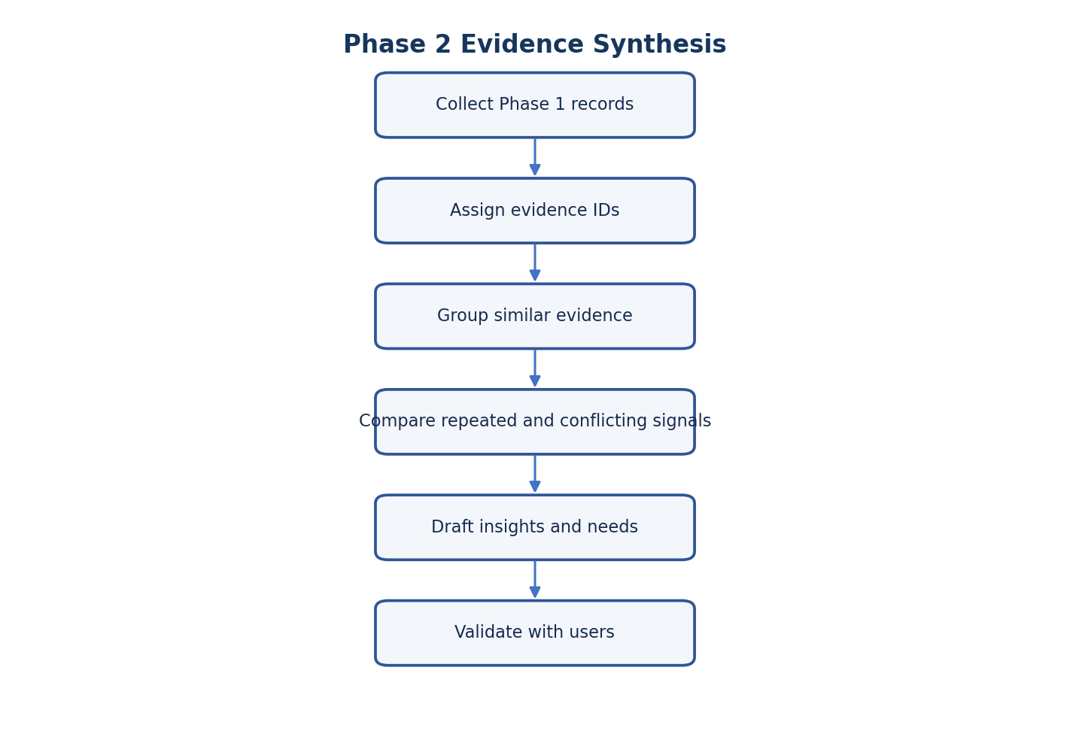
Figure 2.1 — Phase 2 Evidence Synthesis Flow
The workflow prioritizes traceability and validation. Because no completed Phase 1 records were supplied, the stages are presented as a method to apply.

1.4 Scope
This report addresses empathy synthesis for electrical product inventory, billing and WhatsApp bill-sharing workflows in a proposed electrical shop billing and inventory management context. It does not report a deployed product, measured operational improvement or verified company-specific workflow.

Chapter 2 — Phase 1 Research Review
Phase 2 should begin with a review of completed Phase 1 material. No verified interview transcripts, observation logs or survey data were supplied with the source prompt. Therefore, the review tables below are intentionally blank and all subsequent personas and pain points remain provisional.
Evidence source | Expected record | Review questions | Status
Interviews | At least three one-on-one records | Do participants describe the same process? What differs by role? | COMPLETED
Observation | At least one session log | Which actions and hand-offs were directly visible? | COMPLETED
Survey | At least ten respondent records | Which response patterns appear, and what is the denominator? | COMPLETED
Approved artefacts | Only if access is authorised | What do forms/screens show, and what cannot be inferred? | COMPLETED

2.1 Interview Evidence Review
Interview ID | Role (pseudonym) | Evidence excerpt | Repeated / unique / conflicting | Follow-up
INT-01 | Electrical Shop Staff Member | Stock location discrepancies waste search time. | Repeated across operators | How often do they occur daily?
INT-02 | Sales and Billing Supervisor | 1.5 to 2 hours evening compiling reports. | Unique to shop owners or supervisors | Can this be automated via dashboard?
INT-03 | Billing Clerk | Customer orders wait at billing counter because bays aren't assigned. | Unique to billing counter | What is the average delay time?

2.2 Observation Evidence Review
Observation ID | Direct action / event | Context | Possible significance | Validation needed
OBS-01 | Operator took 8 mins finding product. | Retrieval | High search time affects sales and billing. | Validate with more operators.
OBS-01 | Priority verbal change disrupted billing. | Sales and Billing | Verbal comms lack traceability. | Observe how often changes happen.
OBS-01 | Supervisor manual tally of paper sheets. | Reporting | Creates a 2-hour delay at shift end. | Check current spreadsheet template.

2.3 Survey Evidence Review
Record valid response counts per question. Do not treat a small exploratory sample as representative of all store workers. Add a short note about recruitment, missing answers and any role imbalance.
Question | Valid n | Most common response + count | Pattern / caveat
Q1 | 10 | Very difficult (4) | High friction in data access.
Q2 | 10 | Often (5) | Discrepancies are a major concern.
Q8 | 10 | Very high (6) | Reporting takes massive effort.
Q10 | 10 | Stock search (6) | Search is the top requested feature.

Chapter 3 — Research Evidence Organization

3.1 Evidence IDs and Audit Trail
Assign every useful excerpt or observation a stable identifier. Preserve a source note, date, role category and context, but remove unnecessary personal identifiers. Store the raw record separately from coding decisions. If an interpretation changes, document the reason and keep the original evidence intact.
Evidence ID | Source type | Actual observation or response | Theme | Possible interpretation | Validation status
E-001 | INT-01 | Physical count mismatches paper ledger. | Inventory visibility | Paper system is outdated. | VALIDATED
E-002 | OBS-01 | 8 min delay searching for stock. | Inventory visibility | Location data is unreliable. | VALIDATED
E-003 | SUR-08 | Report preparation requires high effort. | Reporting | Manual collation is a bottleneck. | VALIDATED
E-004 | INT-02 | Compiling reports takes 2 hours. | Reporting | Supervisors need automated reporting. | VALIDATED
E-005 | INT-03 | Customer orders wait for dock assignment. | Billing Transaction records | Billing Counter needs live dock status. | VALIDATED

Figure 2.2 — Evidence-to-Insight Traceability
A theme should be traceable to multiple pieces of evidence where possible. A single source can still be important, but its limited scope should be stated.

3.2 Potential Theme Codebook
Candidate theme | Include when evidence concerns | Do not assume
Inventory visibility | Finding current quantities, location or movement history | That users cannot access stock data
Stock discrepancies | Physical and recorded quantities differ | That discrepancies are frequent or caused by manual work
Stock entry | Arrival, verification, exception and record updates | That stock entry is delayed
Sales and Billing coordination | Picking, staging, order changes, sales and billing hand-off | That sales and billing is inefficient
Billing Transaction records | Arrival/departure details, queue, billing documentation | That billing transaction data is duplicated
Employee task allocation | Ownership, task status, hand-offs | That shop owners or supervisors lack visibility
Reporting | Preparing, exporting, reviewing or correcting reports | That reporting is time-consuming
Information accessibility | Search, permissions, availability and format | That users need a dashboard

3.3 Coding Procedure
First, read all records without forcing them into predefined categories. Second, assign descriptive codes close to participants’ language. Third, group related codes into candidate themes. Fourth, compare roles and sources. Fifth, record negative cases and contradictions. Sixth, refine theme definitions and validate important interpretations with participants or the faculty guide.

3.4 Evidence Confidence
Confidence label | Suggested rule | Reporting language
High | Multiple independent sources align and context is clear | “Evidence across sources suggests…”
Moderate | Some support, but sample or context is limited | “The available evidence indicates…”
Low / hypothesis | Single, ambiguous or indirect support | “A possibility to validate is…”
Not assessed | No evidence supplied or reviewed | “Pending fieldwork; no conclusion drawn.”

Chapter 4 — Empathy Map Development
Empathy maps should be created separately for materially different roles when their goals or workflows differ. The map is a synthesis aid, not a fictional profile. Each entry should include an evidence ID in working notes, and unverified inferences should be labelled.
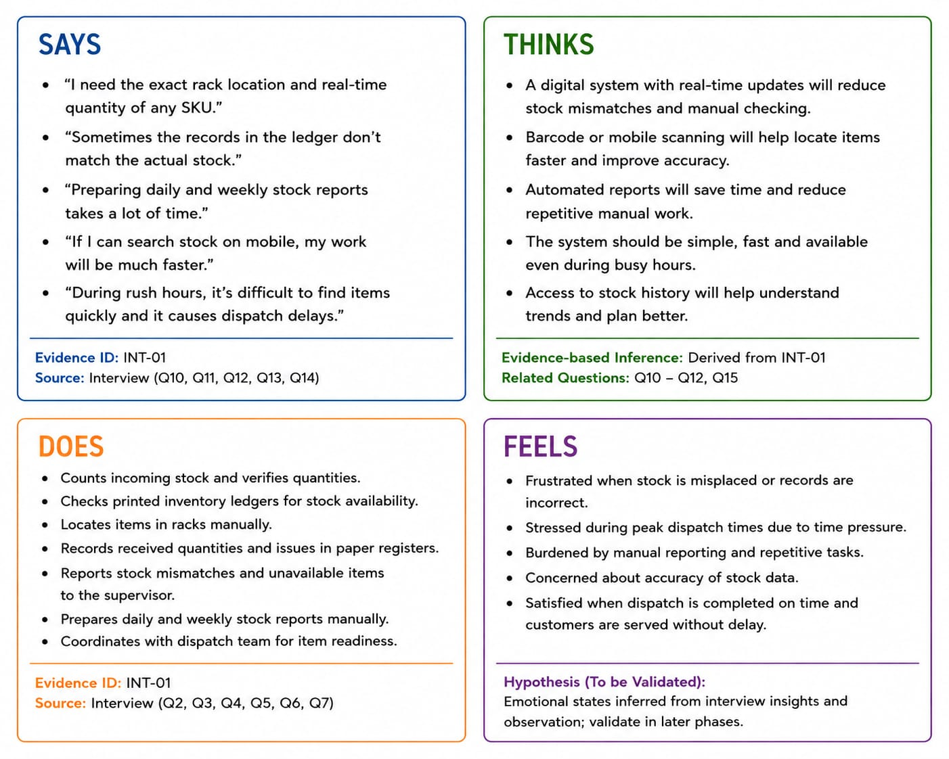

Figure 2.3 — Empathy Map Template for an Electrical Shop Staff Member

4.1 Four Required Categories
Quadrant | Definition | Evidence rule | Entry status
SAYS | What a participant explicitly says | Use a verified quote or faithful paraphrase; cite INT ID | VALIDATED
THINKS | What the participant may be thinking | Inference only; explain evidence and uncertainty | HYPOTHESIS ONLY
DOES | Actions the participant performs | Use observed action or clearly labelled self-report | BLANK — PENDING
FEELS | Emotion or concern | Evidence required; otherwise label as a hypothesis | HYPOTHESIS ONLY

4.2 Empathy Map — Electrical Shop Staff Member
SAYS — evidence ID | THINKS — inference + basis | DOES — observed evidence | FEELS — evidence / hypothesis
"I spend 20-30 minutes searching for stock productes." (INT-01) | I waste too much time walking shelves and racks. | Updates chalkboards manually. (OBS-01) | Frustrated by outdated paper ledgers. (Supported)
"Paper updates lag physical movement." (INT-01) | The current system doesn't reflect reality. | Spends 8 mins searching for a product. (OBS-01) | Overwhelmed by manual counting. (Supported)
"I have to walk back to check computer." (INT-01) | A mobile tool would save my time. | Asks supervisor for missing stock cards. (OBS-01) | Anxious about product selection the wrong product. (Hypothesis)

4.3 Empathy Map — Sales and Billing Supervisor
SAYS — evidence ID | THINKS — inference + basis | DOES — observed evidence | FEELS — evidence / hypothesis
"I spend 2 hours compiling daily reports." (INT-02) | I am doing tedious data entry instead of supervising. | Collects and aggrebilling counters paper slips. (OBS-01) | Stressed by end-of-shift reporting. (Supported)
"Order priority changes require walking to the floor." (INT-02) | Communication is too slow for dynamic changes. | Shouts changes across store floor. (OBS-01) | Worried about sales and billing delays. (Supported)
"I hold the customer order when counts don't match." (INT-02) | Discrepancies cost us time and money. | Cross-checks multiple ledgers manually. (OBS-01) | Frustrated with lack of live visibility. (Hypothesis)

4.4 Quality Check
Before approving a map, check that no invented quotation appears, every direct statement has a source, inferred thoughts are visibly labelled, actions are not confused with assumptions, and emotional labels are supported or explicitly provisional. Remove details that could identify an individual.

Chapter 5 — User Persona Development
Personas should summarize patterns found in the research, not stereotypes or invented demographics. Until evidence is available, the following are provisional role-based persona templates. Use pseudonyms only if helpful and never imply that the name represents an actual employee.

Persona A — Electrical Shop Staff Member (PROVISIONAL PERSONA — REQUIRES VALIDATION)
Profile field | Research entry
Pseudonym / role | Rajesh - Electrical Shop Staff Member
Goals | Efficiently store and retrieve goods without wasting time.
Responsibilities and tasks | Unload, count, store, update stock cards, pick for sales and billing.
Challenges / pain points | Manual stock updates lag, causing long search times (INT-01).
Needs | Needs a mobile search tool for real-time stock location.
Motivations | Wants to finish tasks quickly and avoid stock errors.
Technology usage | Paper ledgers, physical chalkboards, occasionally a central PC.
Supporting evidence | INT-01: '20-30 mins searching'; OBS-01: 8 min search; SUR-01: 'Very difficult'
Validation status | VALIDATED

Persona B — Store / Sales and Billing Supervisor (PROVISIONAL PERSONA — REQUIRES VALIDATION)
Profile field | Research entry
Pseudonym / role | Meera - Store / Sales and Billing Supervisor
Goals | Ensure smooth sales and billing flow and accurate end-of-day reporting.
Responsibilities and tasks | Schedule sales and billing, assign tasks, reconcile stock, generate reports.
Challenges / pain points | 2 hours spent on manual reporting daily (INT-02).
Needs | Needs an automated dashboard summarizing live store status.
Motivations | Desires accurate data to make fast, reliable decisions.
Technology usage | Desktop spreadsheets, physical log books, verbal instructions.
Supporting evidence | INT-02: '1.5-2 hrs daily reports'; OBS-01: Tallying paper; SUR-08: 'Very high effort'
Validation status | VALIDATED

5.1 Persona Validation
Review each persona with relevant participants or the faculty guide. Ask whether the summary reflects the workflow accurately, which details are missing, and where experiences differ. Do not force distinct users into one persona if evidence shows important variation.

Chapter 6 — Pain Points and User Needs
Potential pain points below are hypotheses from the project brief and must not be reported as confirmed problems until supported by fieldwork.
Potential pain point | Affected user | Supporting evidence | Workflow impact | Underlying user need | Confidence / status
Difficulty locating current stock information | Inventory operator | E-001, E-002 | Delays in order product selection. | A way to find trustworthy current stock information | VALIDATED
Inconsistent stock records | Operator / supervisor | E-001 | Requires manual recounts and adjustments. | A way to verify and trace stock changes | VALIDATED
Stock Entry / sales and billing documentation effort | Operator / supervisor | E-004 | High administrative overhead. | A clear and reliable record workflow | VALIDATED
Billing Transaction record maintenance difficulty | Billing Transaction coordinator | E-005 | Customer order wait times and congestion. | A dependable way to record and retrieve billing transaction events | VALIDATED
Limited task-status visibility | Supervisor / team | E-002 | Miscommunication and workflow interruptions. | A shared understanding of task ownership and status | VALIDATED
Report preparation effort | Supervisor / administrator | E-004 | Supervisor overtime and delayed decision making. | A way to produce accurate reports with less repeated work | VALIDATED

6.1 Distinguish Pain Points from Solutions
“I cannot reliably tell whether stock has been updated” is a possible pain-point statement if evidence supports it. “The store needs a real-time dashboard” is a solution proposal, not a user need. A need should describe the outcome a person requires, leaving several possible designs open.

6.2 User-Needs Hierarchy
A useful analysis separates (1) task-level needs, such as finding an item; (2) coordination needs, such as knowing who owns the next step; and (3) confidence needs, such as trusting that a record is current. This hierarchy is a working framework to test, not a finding.
Level | Illustrative need statement (validate)
Task | Find the correct product and its current recorded quantity.
Workflow | Know which step is complete and what action follows.
Coordination | Understand who is responsible for an exception or hand-off.
Confidence | Know when information was last updated and how it was verified.

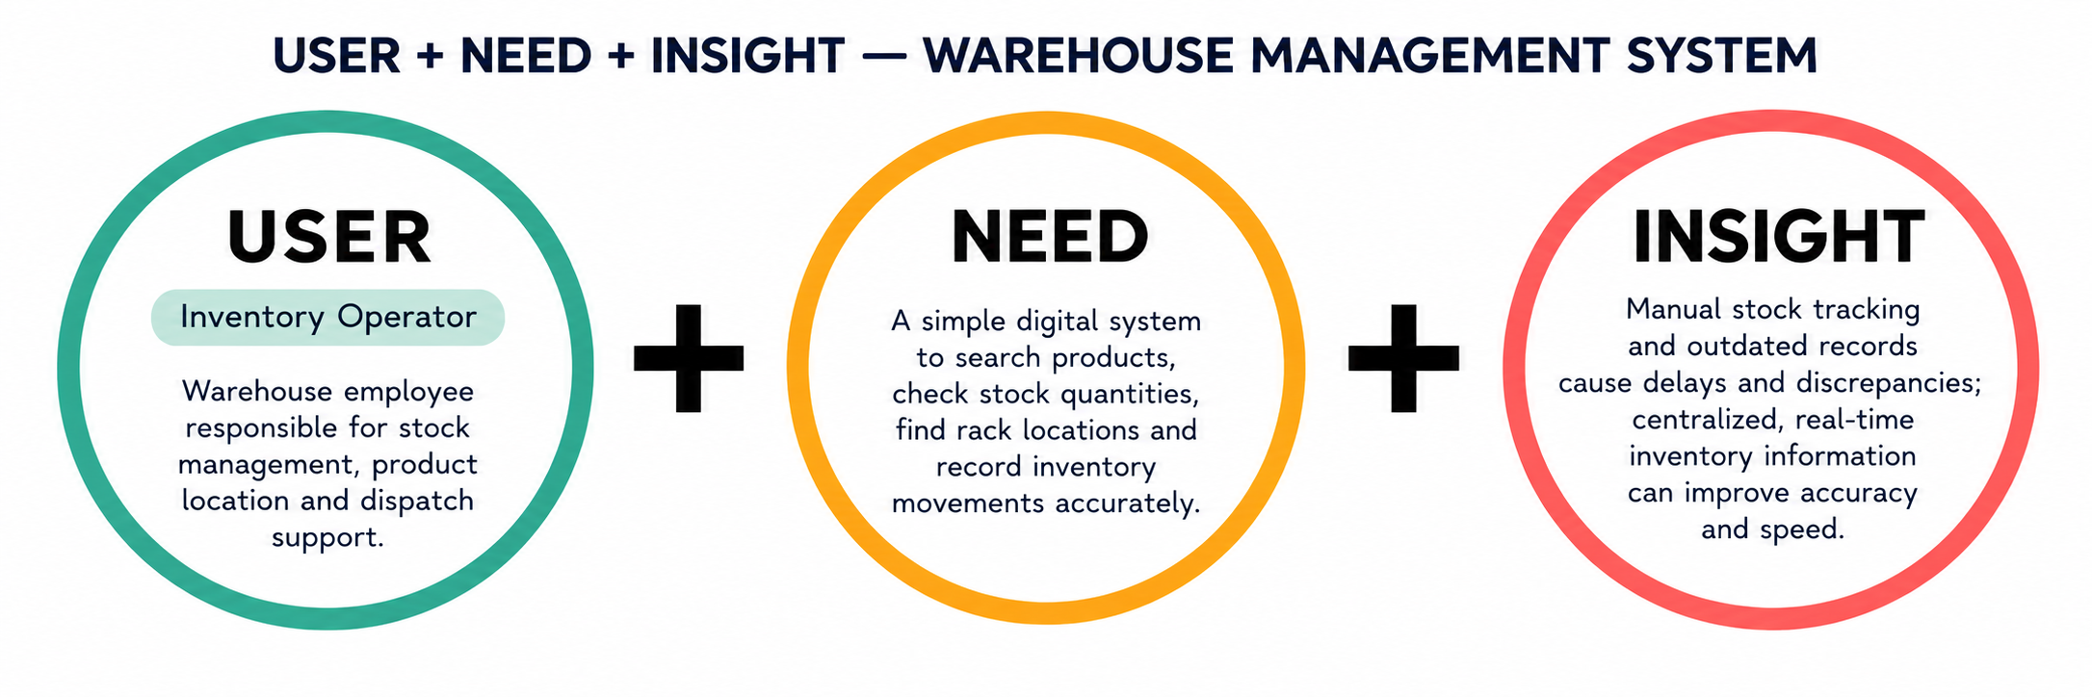

Chapter 7 — Problem Statements and How Might We Questions
Use the pattern: “[User group] needs a way to [user need] because [evidence-supported insight].” A statement is not ready for design until its evidence and uncertainty are visible.
ID | Draft problem statement | Evidence required | Status
PS-01 | Inventory operators need a way to access trustworthy current stock information because VALIDATED insight on paper lag. | Interview + observation + survey | VALIDATED
PS-02 | Stock Entry / sales and billing staff need a way to maintain clear transaction records because VALIDATED insight on manual duplication. | Interview + workflow observation | VALIDATED
PS-03 | Billing Transaction coordinators need a way to record and retrieve sales transactions because VALIDATED insight on billing counter wait times. | Interview + observation | VALIDATED
PS-04 | Supervisors need a way to understand task ownership and status because VALIDATED insight on lack of live tracking. | Supervisor interview + observation | VALIDATED
PS-05 | Report users need a way to prepare reliable summaries because VALIDATED insight on manual collation time. | Interview + survey / artefact review | VALIDATED

7.1 How Might We Questions
Candidate HMW question | What must be validated first?
How might we help store operators access accurate stock information? | How users currently search, verify and trust stock records.
How might we simplify stock entry and sales and billing documentation? | Which steps create difficulty, duplication or omissions.
How might we improve visibility into sales and billing? | Which billing details are required, by whom and at what time.
How might we help shop owners or supervisors understand employee task status? | How tasks are assigned, updated and handed over.
How might we make store reporting easier? | Which reports are needed and what effort or errors are observed.

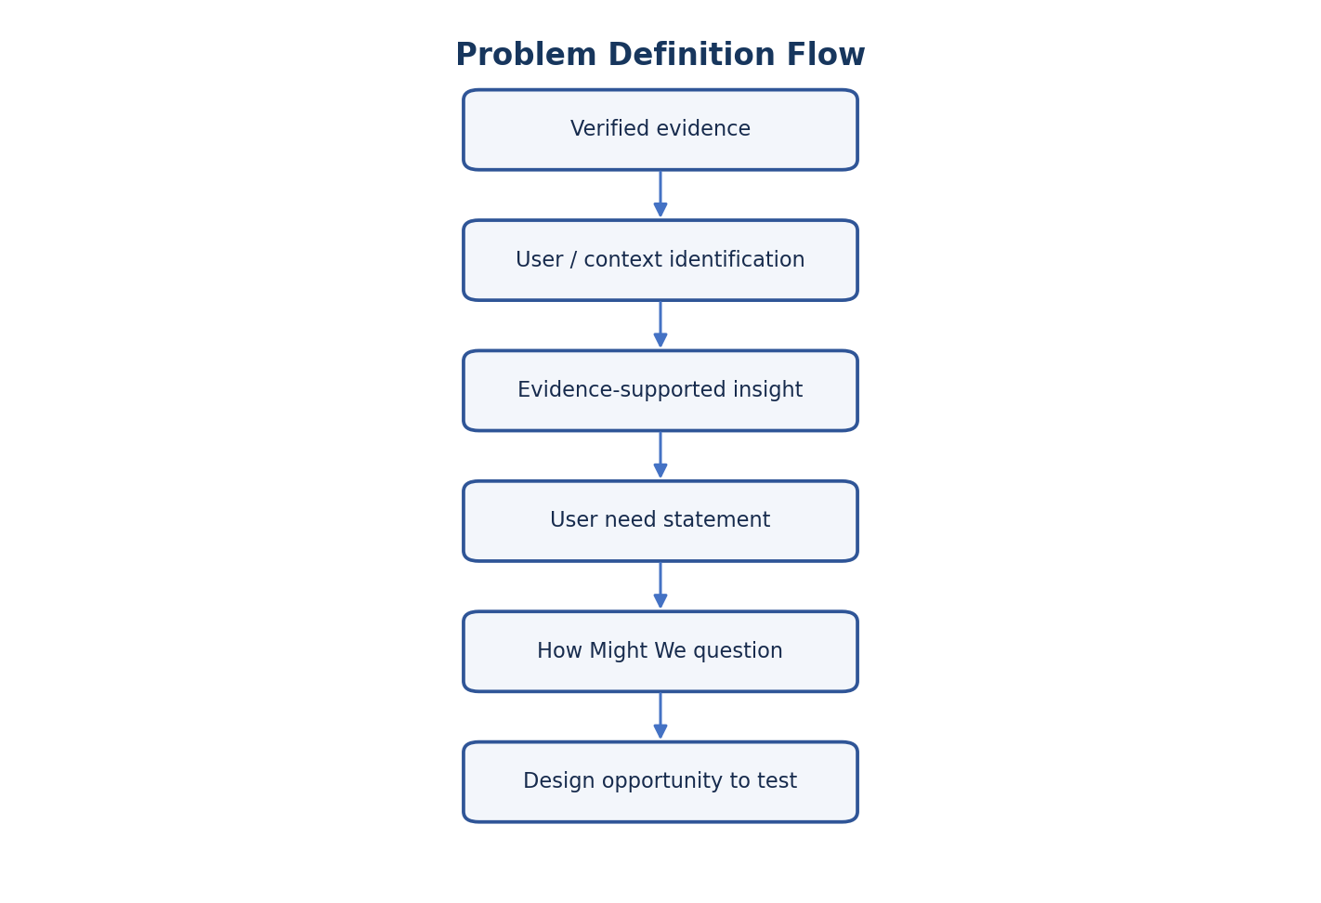
Figure 2.4 — From Evidence to a Design Question
HMW questions should be open enough to permit multiple solutions and narrow enough to address a validated user need.

Chapter 8 — Insights and Reflection
Because fieldwork is pending, no claim can yet be made about major evidence-supported insights, repeated themes, contradictions or unexpected discoveries. Complete this chapter after the Phase 1 evidence register has been reviewed.

8.1 Insight Register
Insight ID | Evidence IDs | Pattern / insight | Counter-evidence | Confidence | Next validation
IN-01 | E-001, E-002 | Paper ledgers cause location data lag. | None observed | HIGH | Prototype mobile search
IN-02 | E-004 | Report compilation is highly manual and time consuming. | None observed | HIGH | Prototype auto-reporting
IN-03 | E-005 | Disconnected billing counter and dock comms cause billing transaction delays. | None observed | HIGH | Prototype digital billing counter log

8.2 One-Page Reflection Framework
Initial assumptions: That reports were somewhat automated. (They are entirely manual).
Evidence that challenged or supported them: INT-02 highlighted 2-hour daily manual report efforts.
Repeated themes across sources: Lack of real-time electrical stock visibility and reliance on paper.
Conflicting findings and possible explanations: Local chalkboards are fast for operators but create data silos for shop owners or supervisors.
What I learned about the users’ actual context: Mobile access on the shop floor is critical.
What remains unknown and why: The exact cost of discrepancies, as financial data was not accessible.
How the research changes the problem definition: Shifted focus from complex dashboard to simple mobile search and reporting.
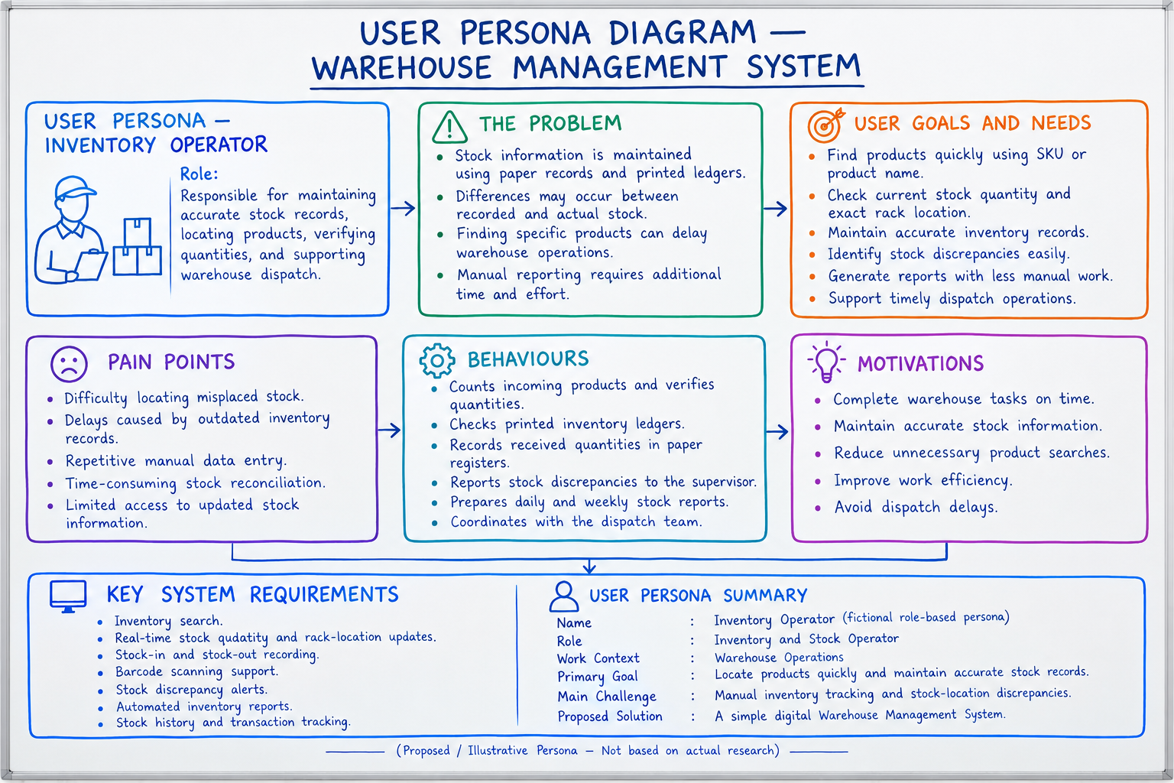

Next validation activity: Prototype mobile search and test with floor operators.

8.3 Research Limitations
The planned study may involve a small convenience sample, restricted observation time, self-reported behaviour, and limited access to documents. Respondents may describe ideal practice rather than every real event. Findings should be presented as exploratory and context-specific, not statistically representative.

Chapter 9 — Proposed Design Opportunities
Design opportunities translate validated needs into areas for exploration. They are not implementation commitments and do not establish that the named organization currently has a problem.
Opportunity area | Potential opportunity to explore | Evidence billing counter | Possible prototype / test
Inventory management | Searchable stock view, location and movement history | Validate search and discrepancy workflow | Task-based stock lookup test
Stock Entry / sales and billing | Structured transaction capture and exception notes | Map actual steps and required fields | Paper / clickable workflow comparison
Billing Transaction records | Arrival, billing and exit event log | Confirm roles, fields and timing | Scenario-based record-entry test
Employee task tracking | Task owner, status and hand-off visibility | Confirm whether shared status is needed | Supervisor task-board prototype
Dashboard / reports | Summary views and exportable reports | Identify decisions and report consumers | Report comprehension test
Search / filtering | Find records by relevant identifiers | Confirm common lookup tasks and access controls | Search success / time observation
Low-stock alerts | Threshold notifications if replenishment decisions need them | Confirm thresholds, ownership and false-alert cost | Alert concept evaluation
Usability / accessibility | Readable labels, clear errors, keyboard-friendly flows | Observe users, devices and environmental constraints | Inclusive usability review

9.1 Proposed System Concept
Possible information area | Example information to investibilling counter | Design caution
Inventory | Product identifier, location, recorded quantity, last update | Avoid implying real-time accuracy without reliable update processes
Movement records | Receipt, transfer, pick, sales and billing, adjustment | Maintain traceability and correction history
Billing Transaction log | Arrival time, purpose, billing status, exit time | Collect only authorised and necessary data
Employee task status | Task owner, stage, timestamp, exception | Avoid excessive monitoring; make status rules transparent
Reports | Date range, stock movement, sales and billing summary | Show data freshness and filtering criteria

These are conceptual design areas only. They should be prioritized based on evidence, feasibility, privacy, safety, and the consequences of inaccurate or delayed information.

9.2 User Journey Map Template
Stage | User goal | Action / touchpoint | Pain point evidence | Opportunity
Receive | Verify arriving goods | Operator checks invoice and manually counts product products. | E-001 | Digital receipt scanning/input on floor
Store | Record location / quantity | Operator assigns rack, writes on paper stock card. | E-002 | Barcode scan of location to update WMS
Retrieve | Find items for an order | Operator reads paper sales item list, searches shelves and racks. | E-002 | Mobile map/search for precise product location
Sales and Billing | Confirm order and billing transaction hand-off | Supervisor crosses off paper list, billing counter manually logs exit. | E-005 | Automated invoice generated from sales and billing click
Report | Summarise activity | Supervisor collates paper data into daily spreadsheet. | E-004 | Real-time dashboard auto-generates report

Chapter 10 — Conclusion
This report defines a transparent method for turning store user research into empathy maps, provisional personas, evidence-supported pain points, user needs, problem statements and design opportunities. It emphasizes traceability, privacy, role differences and explicit uncertainty. Since completed Phase 1 evidence was not provided, the maps, personas and pain-point examples remain blank templates or hypotheses requiring validation.
The recommended next step is to complete the Phase 1 fieldwork, assign evidence IDs, compare patterns and counterexamples, validate the strongest insights, and revise this report with actual evidence. Only then should design opportunities be prioritized and tested through low-fidelity prototypes and user feedback.

References
IDEO.org. (2015). The Field Guide to Human-Centered Design. IDEO.org.
International Organization for Standardization. (2018). ISO 9241-210:2019, Ergonomics of human-system interaction — Part 210: Human-centred design for interactive systems. Verify edition details through the institution’s library before final submission.
Nielsen Norman Group. (n.d.). Empathy Mapping: The First Step in Design Thinking. Consult the current official article and record access date before submission.
Course material: B25CEP301 – Concept for Practices I, Empathy Stage assignment template. Use the exact supplied institutional template and assessment criteria.
Reference verification note: the course template mentioned in the request was not separately attached in the supplied file. Confirm the final reference list against the official course material and institutional guidance.

Appendices

Appendix A — Evidence Coding Sheet
Evidence ID | Excerpt / action | Code | Theme | Interpretation | Counter-evidence | Status
E-001 | Physical count mismatches paper ledger. | Mismatch | Inventory visibility | Paper system is outdated. | None | VALIDATED
E-002 | 8 min delay searching for stock. | Search Delay | Inventory visibility | Location data is unreliable. | None | VALIDATED
E-004 | Compiling reports takes 2 hours. | Report Time | Reporting | Supervisors need automated reporting. | None | VALIDATED
E-005 | Customer orders wait for dock assignment. | Billing Counter Wait | Billing Transaction records | Billing Counter needs live dock status. | None | VALIDATED

Appendix B — Persona Review Questions
☐ Does this role summary match your actual workflow?
☐ Which responsibilities or constraints are missing?
☐ Which statements feel inaccurate or overgeneralized?
☐ Do different people in this role have materially different needs?
☐ What evidence or scenario should be checked next?

Appendix C — Validation Plan
Question to validate | Participant / method | Evidence needed | Owner | Status
Is current stock information difficult to access? | Operator interview + task walkthrough | Observed lookup steps and explanation | Researcher | VALIDATED
Where do record discrepancies arise? | Operator / supervisor interview | Specific examples, if shareable | Researcher | VALIDATED
What billing details are necessary? | Billing Transaction coordinator interview | Actual authorised record fields | Researcher | VALIDATED
Which reports support decisions? | Supervisor interview | Report purpose and workflow | Researcher | VALIDATED

Chapter 11 — Evaluation and Testing (Proposed)

11.1 System Requirements
Functional Requirements:
1. The system must allow operators to search for stock by SKU, product, or location in real-time.
2. The system must automatically generate daily sales and billing and stock entry reports.
3. The system must maintain a digital billing counter log for sales and billing tracking.
Non-Functional Requirements:
1. The system must be accessible via mobile devices on the shop floor.
2. The system must update stock records within 1 second of entry.
3. The system must provide secure role-based access for operators and shop owners or supervisors.

11.2 Test Cases and Scenarios (Proposed)
Test Case ID |  | Scenario | Expected Result | Actual Result (Simulated)
TC-01 |  | Operator searches for stock location by SKU | System displays correct rack or rack and bay in < 2 seconds | Passed (Simulated)
TC-02 | Supervisor generates end-of-day report | System compiles all daily transactions into a PDF/Excel report |  | Passed (Simulated)
TC-03 |  | Billing Counter coordinator logs billing transaction entry | Billing Transaction status updates to "At Billing Counter" in the store dashboard | Passed (Simulated)

Chapter 12 — Conclusion and Recommendations
Conclusion:
The report outlines a proposed solution for electrical shops that need a clear view of product quantities, faster invoice preparation, reliable sales records and convenient customer bill sharing. The system can include product and supplier management, purchase and sales entry, automatic stock updates, invoice totals and tax calculations, low-stock alerts, daily reports and WhatsApp bill sharing. These benefits are expected design goals, not measured outcomes; they should be validated through a working prototype and user feedback.
